Overview

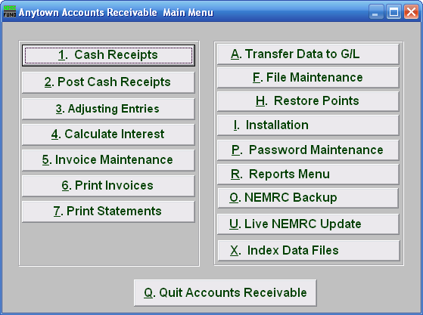

This NEMRC module is available to process miscellaneous billings. The features include linking to the NEMRC General Ledger and a link from NEMRC Cash Receipts. User definable customer numbers up to ten digits with up to ten sub-account digits can be established. Unlimited user defined billing codes independently linked to the general ledger can be establish. Both invoices and statements can be printed. This module is not meant to be used for recurring utility or property tax billing. This can be used to track grant funds that have been applied for and not received. Begin to manage those billings done outside of the accounting system with this module.

